Specification for HYUNDAI DHY22KSEM

27.5kVA Single Phase Standby Diesel Generator
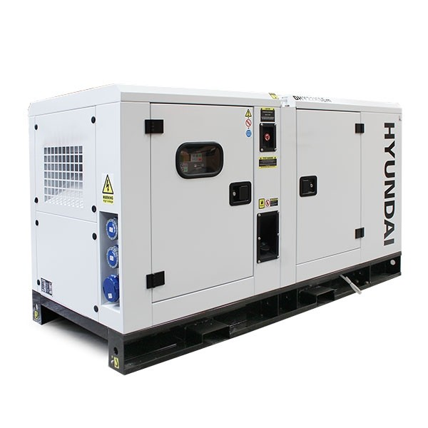 | 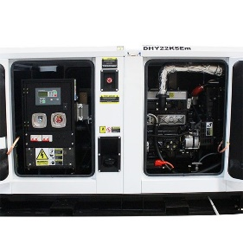

POWER OUTPUT | Prime Power 20kW/25kVA Stand By 22kW/27.5kVA
Rpm | 1500
ENGINE DISPLACEMENT CC | 3298cc
ENGINE MAKE | Hyundai
ENGINE TYPE | HY4100, 4 Cylinder
FUEL TANK CAPACITY | 93 Litres
FUEL TYPE | Diesel
NOISE LEVEL IN DB(A) | 65dB(A) @ 7m
Voltage @50Hz | 240
START | Electric
RUN TIME | 21 Hours @ 50% Load
connection method | Hardwire / 1 x 32Amp 1 x 15Amp IP67 Outlets
Warranty | 1 Year
DIMENSIONS | 2200 x 950 x 1240 mm
WEIGHT | 870kg
COMES WITH | User Manual

